

**Ndola Homes - Real Estate Platform Project Report**

**Prepared by:**

Mwila Mathews 2300612

Simbeye Luckson 2300523

Chileshe Micheal 2300562

Chilufya Felix 2300500

**Date:** October 2025

**Chapter One: Introduction**

**1.1 Introduction**

Ndola Homes is an innovative real estate platform tailored for the Ndola, Zambia property market. It provides a modern solution for property seekers, sellers, and administrators by offering property listings, advanced search capabilities, user authentication, and communication tools. The system is developed using Node.js, Express, SQLite, and deployed via Netlify with serverless architecture.

**1.2 Problem Statement**

The Ndola property market lacks a centralized, modern, and user-friendly online platform for property discovery and management. Existing platforms are fragmented, outdated, and not localized for Ndola, making property search and communication inefficient.

**1.3 Objectives**

* To design and implement a comprehensive real estate platform for Ndola.
* To enable advanced search and filtering capabilities.
* To implement secure user authentication and role-based management.
* To develop an admin dashboard for property management.
* To integrate email notifications and real-time features.
* To ensure scalability and mobile responsiveness.

**1.4 Research Questions**

* How can a modern real estate platform improve property discovery in Ndola?
* Which technologies ensure security and scalability for such a system?
* How can administrators efficiently manage users and properties?
* What communication features are essential for buyers, renters, and sellers?

**1.5 Scope and Limitation**

The system targets Ndola but can expand to other cities. It supports property sales and rentals, admin/user roles, and integrated communication. Limitations include the use of SQLite in a serverless environment and limited property data at launch.

**1.6 Significance of the Study**

This study provides a modern platform for Ndola’s property market, helping buyers, renters, and property owners while offering a scalable solution adaptable to other Zambian cities.

**1.7 Conceptual Framework**

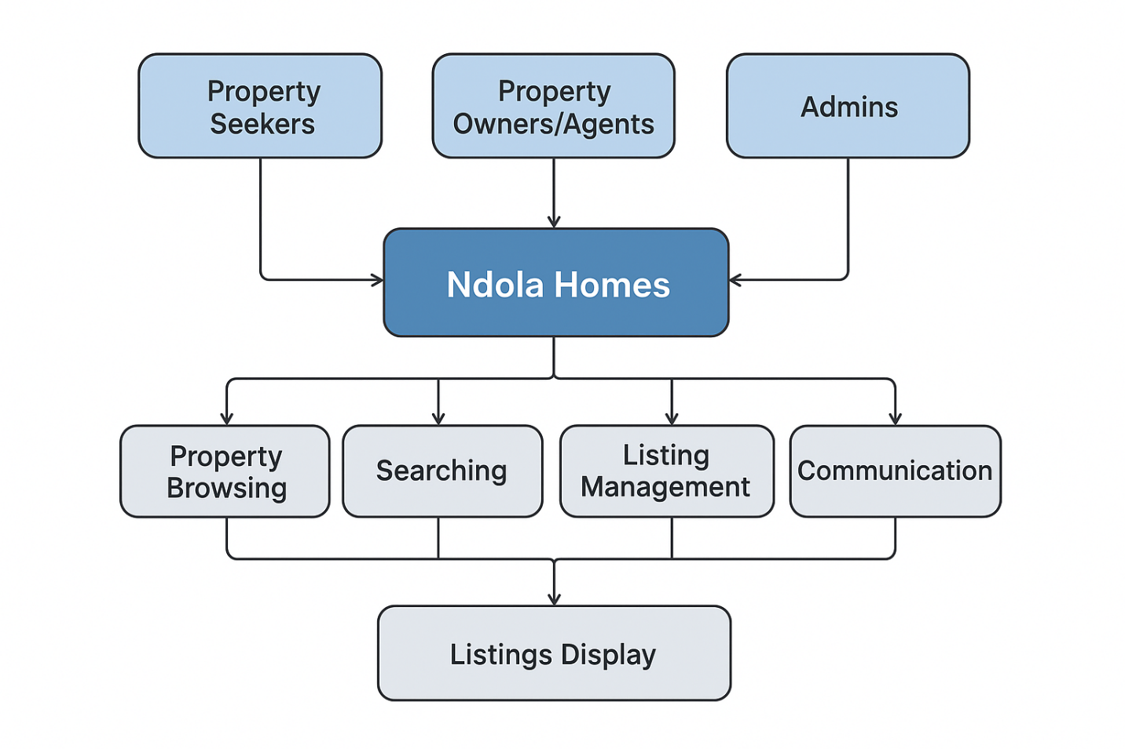**1.8 Organisation of the Report**

* Chapter One: Introduction
* Chapter Two: Literature Review
* Chapter Three: Methodology
* Chapter Four: System Design and Implementation
* Chapter Five: Results and Discussion
* Chapter Six: Conclusion and Recommendations

**Chapter Two: Literature Review**

**2.1 Introduction**

This chapter reviews related works and existing property platforms globally and locally.

**2.2 Related Works**

* **Global platforms**: Zillow, Realtor — advanced features but not localized.
* **Zambia platforms**: Property24 — provides listings but lacks scalability, modern UX, and serverless architecture.

**2.3 Review of Related Works**

Existing solutions show gaps in localization, scalability, and user experience. Ndola Homes aims to bridge this gap with lightweight technology and mobile-first design.

**2.4 Proposed System**

Ndola Homes introduces:

* Listings with advanced filtering.
* Role-based access control.
* Contact and inquiry system.
* Serverless deployment.
* Secure authentication.

**2.5 Summary**

The review justifies the development of Ndola Homes as a localized yet modern solution.

**Chapter Three: Methodology**

**3.1 Introduction**

This chapter outlines the adopted methodology, requirements gathering, and validation.

**3.2 Software Development Methodology**

The **Agile methodology** was adopted. Iterative sprints allowed continuous feedback and fast response to deployment and database challenges.

**3.3 Requirements Specification**

**3.3.1 Stakeholders**

* Property Seekers
* Property Owners/Agents
* Administrators
* Developers

**3.3.2 Requirements Gathering**

Gathered from competitor analysis, local market observation, and informal surveys.

**3.3.3 Requirements Analysis**

**Functional Requirements**

* Browse and search properties.
* Create accounts and login.
* Admin dashboard for property/user management.
* Contact forms with email notifications.

**Non-Functional Requirements**

* Secure authentication.
* Responsive design.
* Scalability.
* High performance.

**Requirements Validation**  
Validated through prototype testing and debugging tools.

**3.4 Summary**

Agile ensured adaptability and user-focused development.

**Chapter Four: System Design and Implementation**

**4.1 Introduction**

This chapter describes the system design, models, and implementation.

**4.2 Architectural Design**

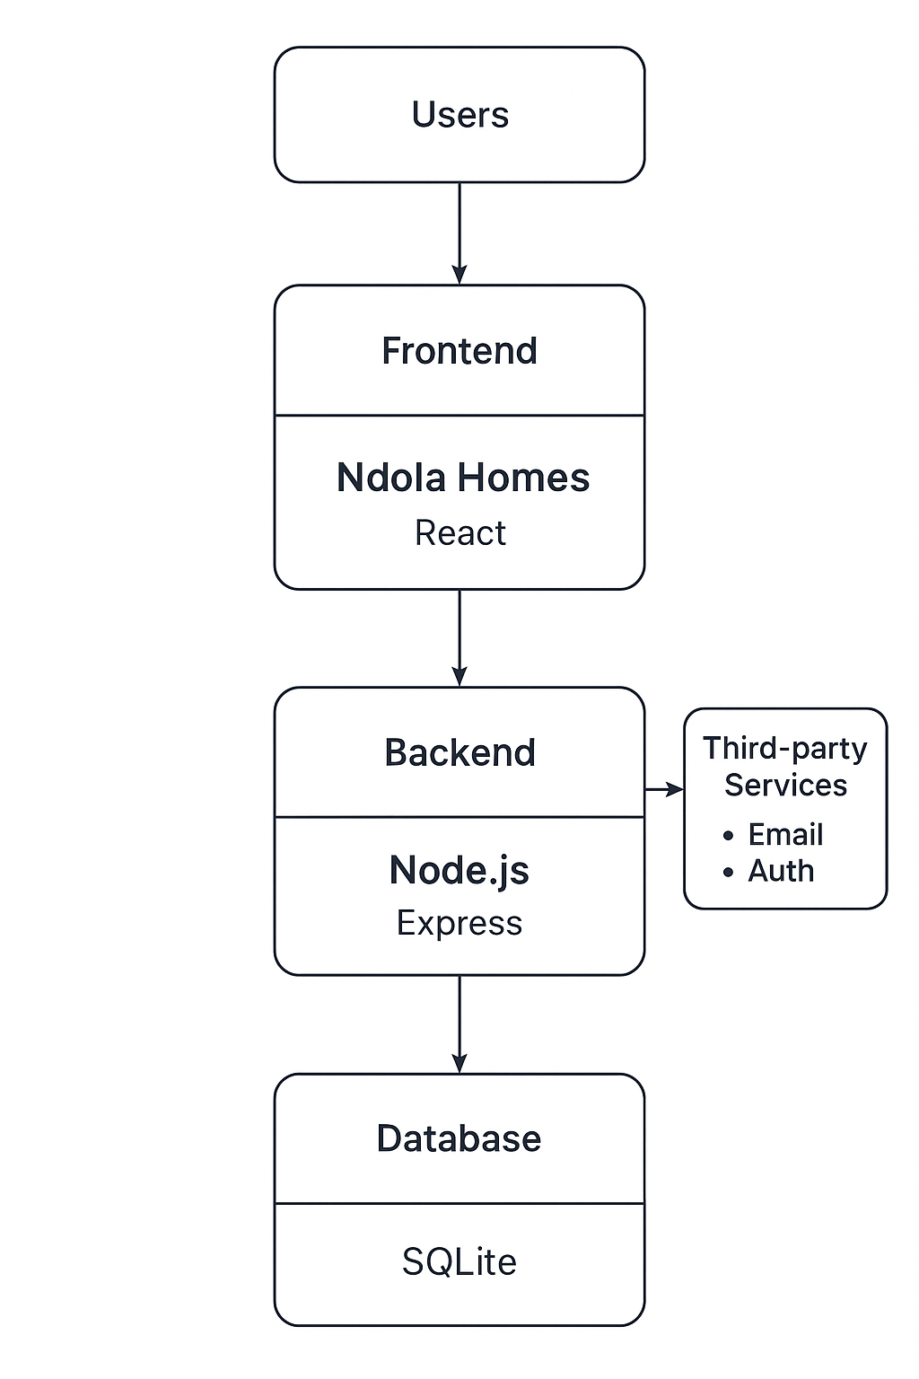**4.3 Software Design**

**4.3.1 Tools**

* VS Code, GitHub, Netlify, SQLite.
* Lucidchart/diagrams for modeling.

**4.3.2 Component Design**

* **Contextual Model** → Users, Listings, Communication, Admin.
* **Use Case Model** → **[Insert Diagram: Use Case Diagram]**
* **Sequence Diagram** → **[Insert Diagram: Sequence Diagram]**
* **Class/ERD Diagram** → **[Insert Diagram: ERD]**

**4.4 Software Development**

Implemented in Node.js and Express. SQLite database stores listings, users, and media. JWT handles authentication.

**4.5 Deployment**

Deployed on Netlify with GitHub integration. Environment variables handle sensitive data.

**4.6 Summary**

The design ensures modularity, scalability, and maintainability.

**Chapter Five: Results and Discussion**

**5.1 Introduction**

Presents platform testing results.

**5.2 Results**

* Functional features: listings, search, admin dashboard, email notifications.
* Performance: <500ms average API response.
* Accessibility: WCAG compliance for core features.

**Homepage Property Listings**

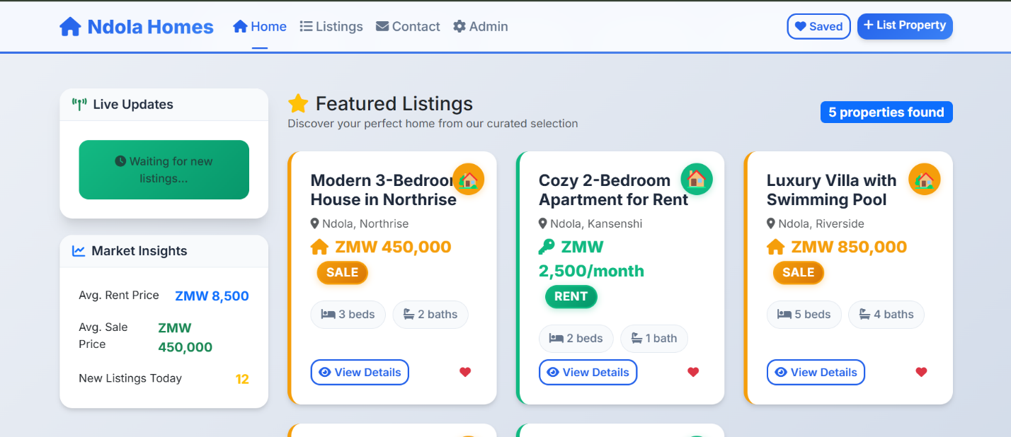  
**Login/Signup Page**

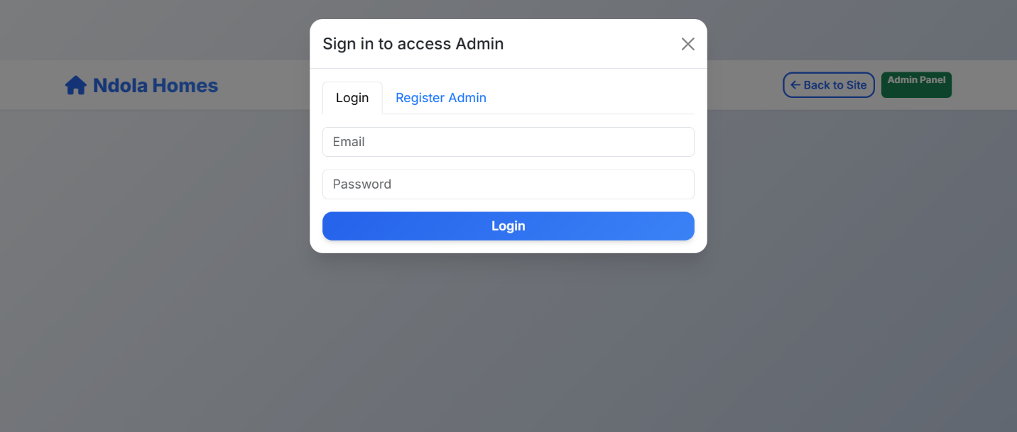  
**Admin Dashboard**

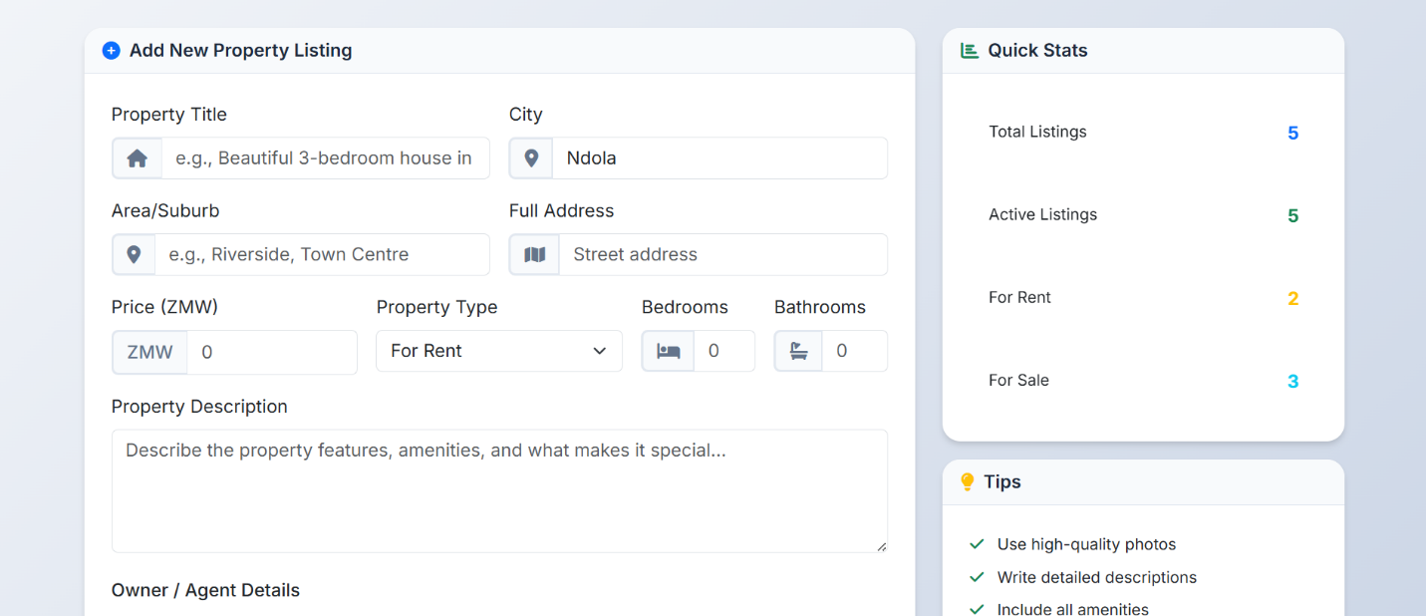

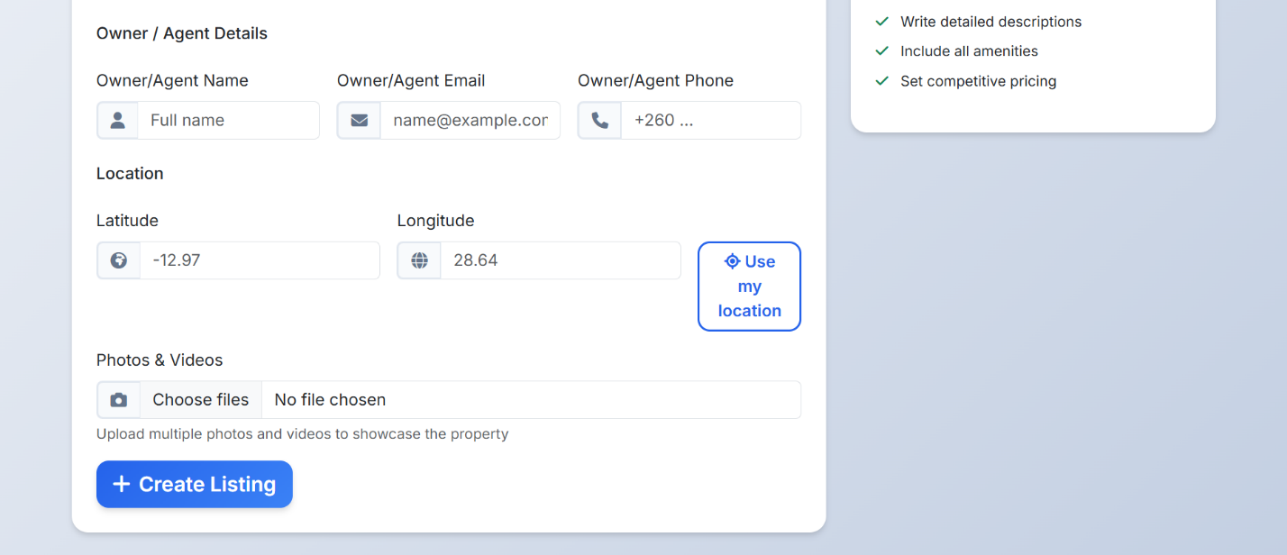

**5.3 Discussion**

Ndola Homes outperforms existing platforms in localization, scalability, and responsiveness. Deployment challenges were solved through database seeding and environment setup.

**5.4 Summary**

The results confirm readiness for production.

**Chapter Six: Conclusion and Recommendations**

**6.1 Introduction**

This chapter concludes the project.

**6.2 Conclusion**

Ndola Homes successfully delivered a modern, localized real estate platform. It solved challenges in property discovery, management, and communication while ensuring scalability.

**6.3 Recommendations**

* Integrate real data APIs.
* Add payment gateways (MTN, Airtel, Visa).
* Develop a React Native mobile app.
* Expand coverage to other Zambian cities.
* Explore AI for recommendations and analytics.

**6.4 Summary**

The platform lays a strong foundation for future growth in Zambia’s digital property market.

**References**

1. Zillow – Global Property Marketplace.
2. Property24 Zambia – Property Listings.
3. Express.js Documentation.
4. SQLite Official Documentation.
5. Netlify Documentation – Serverless Functions.
6. Bootstrap 5 Documentation.

**Appendices**

* Appendix A: Database Schema (Listings, Users, Media).
* Appendix B: API Endpoints List.
* Appendix C: Sample Data Seeding Scripts.